Q7 (1). 

Q7(2). 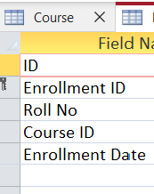

Q7(3)

Q7(4).

Q7(5).

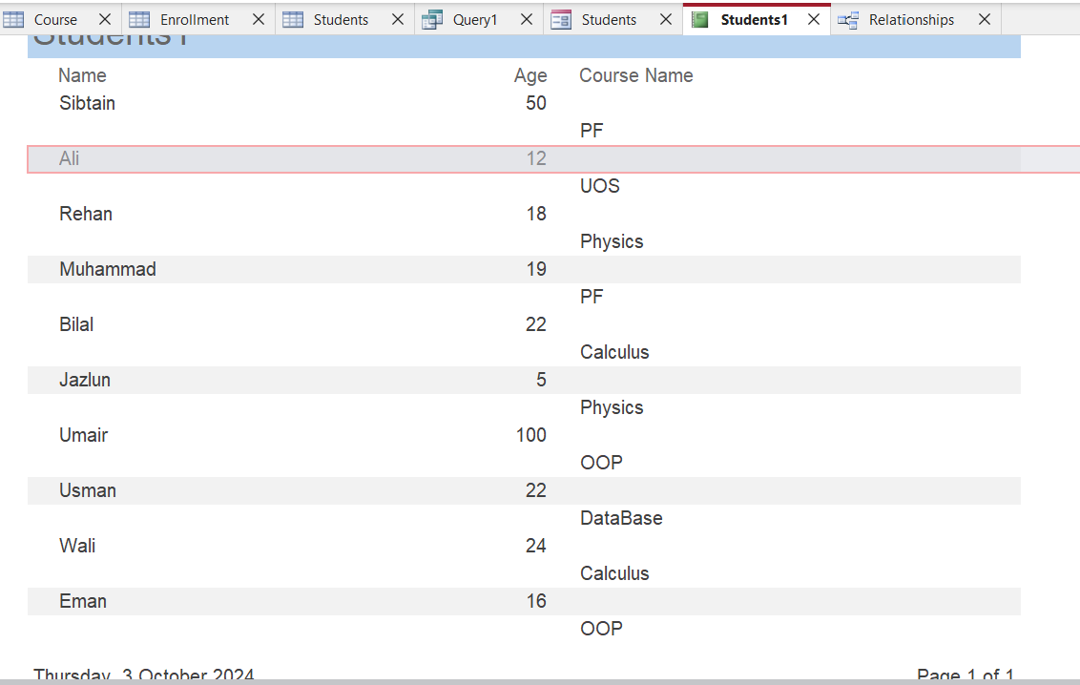

Q8.

**1. One-to-One Relationship**

**Definition**: In a one-to-one relationship, a record in Table A is associated with exactly one record in Table B, and vice versa.

**2. One-to-Many Relationship**

**Definition**: In a one-to-many relationship, a record in Table A can be associated with multiple records in Table B, but a record in Table B is linked to only one record in Table A.

**3. Many-to-Many Relationship**

**Definition**: In a many-to-many relationship, a record in Table A can be associated with multiple records in Table B, and a record in Table B can also be linked to multiple records in Table A.

Q8.(a)

One to Many relationship are implemented between Course & Enrollment and Student & Enrollment

Q8. (c)

Referential integrity ensures that every order corresponds to an existing customer. Maintaining referential integrity supports compliance with regulations and auditing requirements by ensuring that the data is accurate, consistent, and traceable.